MAY 21 2019

Harwood Hutton joins Abacus Worldwide adviser network
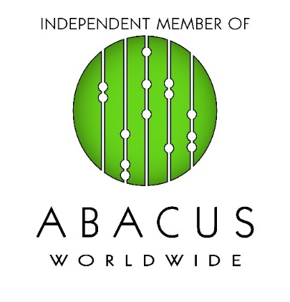
Harwood Hutton, one of the UK’s leading firms of accountants, tax specialists and business advisers, has joined Abacus Worldwide, an association of independent accounting, consulting and legal firms.

Abacus connects high-calibre professional services providers across the globe so they can provide member firms with the knowledge and resources they need to grow and flourish in today’s multi-faceted business environment.

John Brace, managing director of Harwood Hutton, said: “We are a multi-disciplinary firm which has a long tradition of providing tactical and strategic support to companies and individuals at home and abroad. Joining Abacus allows us to connect globally with accounting and law firms of a similar entrepreneurial mind-set.”

Julio Gabay, President and CEO of Abacus Worldwide, said: “With its offices in central London and Beaconsfield, in the Thames Valley, close to Heathrow, Harwood Hutton enhances our presence in the UK and adds considerable value to the EMEA region. We are delighted to have the firm on board.”

A number of Harwood Hutton’s directors have experience in senior positions with the UK’s so-called ‘Big 4’ accounting firms. The firm has won a series of prestigious UK awards in the past two years including The Finance Monthly Deal Maker of the Year Award 2019 (Adam Stronach); The Lawyer Monthly Expert Witness Award (2017); M&A Insider Awards Business and Tax Advisor Firm of the Year (2017) and the Global 100 Forensic Accountant of the Year Award Winner (2017).

Harwood Hutton has actively assisted clients across Europe, North and South America, the Middle East, Africa and Asia. Familiar with many cultures, the international team speak a number of European and Asiatic languages, including Cantonese, Mandarin, Gujarati, French and Portuguese. Harwood Hutton’s specialist foreign direct investment (FDI) service is available to overseas entities looking to establish operations in the UK or mainland Europe. In 2018, Harwood Hutton established a specialist customs and international trade unit.

Harwood Hutton provides tax planning advice to executives on issues such as the UK tax implications of group strategy, efficient international structuring and transfer pricing arrangements. It can also offer guidance on the many options for raising finance in the UK, and once the entity is established, Harwood Hutton can handle ongoing tasks such as preparation of monthly management accounts, VAT advice and returns and payroll processing.

Harwood Hutton advises firms in a number of key sectors, including aerospace, automotive, retail, media and creative industries, health, IT and property and construction.

CONTACT
For more information, contact Tony Cheverall, Head of Communications, on +44 (0)1494 739500 or at tonycheverall@harwoodhutton.co.uk

